**Does Salt Increase the Boiling Point of Water**

**Student Name**

**Natural Sciences Lab**

***Section I: Introduction and Literature Review***

A. When adding salt (NaCl) to water (H2O) you raise the boiling point of the water from the breakdown of salt (NaCl) into sodium (Na) and chloride (Cl) ions. This raising of the boiling point is called boiling point elevation and occurs when adding a non-volatile solute to a solvent. When the salt (NaCl) is added to the water (H2O) the breakdown alters the intermolecular forces, the attraction of the water molecules, between the water (H2O) molecules (Helmenstine, 2019).

The energy needed to boil water is 1 calorie of energy to raise 1 gram of water by 1 degree but the feet above sea level changes. In order for water to boil the pressure of the water vapor has to equal the pressure of the atmosphere at that particular level about seal level. Therefore water will boil at a lower temperature the higher you are above sea level. When adding salt to the water the water will heat faster than water without salt added. (Geggel, 2016)

***Section II: Hypothesis***

B. When increasing the grams of salt added to 700g of distilled water by weight, the salt will increase the boiling point of the water and increase the highest sustained temperature of the water over a given time of 10 seconds at 554’ above sea level once the water is boiling. The peak sustained temperature and boiling point should be reached with 700g of water by weight and 90g of salt.

C. Based on research when adding salt to water it increases the boiling point of the water in the process called boiling point elevation. Increasing the boiling point of water then also increases the highest sustained temperature of the water when salt is added, and a solution is created. With this, in the tests performed the water solution with the highest salt ratio should also attain the highest sustained temperature and boiling point.

***Section III: Method***

D. The independent variable will be iodized table salt. It will be manipulated by the lack of salt in the water for the first test. The second test 30g of salt will be added to the water and allowed to dissolve. For the third test 60g of salt will be added to the water and allowed to dissolve. And for the fourth and final test 90g of salt will be added to the water and allowed to dissolve.

E. The dependent variable will be the time it takes the water to reach the highest sustained temp for 10 seconds. This time will be measured with two stop watches. One stopwatch will count the time it takes to reach the highest sustained temperature and the second will measure the 10 seconds for the counted for the sustained temperature. All time will be measured in minutes starting from zero and all temperatures will be measured in Ferin height.

F. The three external confounding variables in this experiment is the stove used, the pot used to boil the water, and the initial temperature of the distilled water. To assist in controlling these two variables I will be doing the following: always use the same stove burner, the same pot, and the same source of water.

On the stove, I used the same burner set to high in order to mitigate the “time to heat” of the burner. By this, the eye of the stove will always be at the high temperature available for the duration for the experiment and never allowed to cool

On the pot, I used the same aluminum pot to boil the water and salt solution. The pot is cleaned and dried between each use and allowed to cool back to a stable temp. This will help mitigate too much salt or water being added inadvertently between each stage of the experiment.

On the water, I will be using the water from same gallon of distilled water from test to test which has been allowed to come to room temperature before allowed to be brought to a boil. 1 gallon of water will grant enough water from the same source for the duration of the experiment.

G. The materials used for this are a 1-quart aluminum Teflon coated pot with a wall thickness of 3mm, Iodized table salt in the measurements of 30g, 60g, and 90g all weighed on a digital scale, and 1 gallon of distilled water at room temperature. The stove burner used is a radiant heat 7-inch burner with a maximum attainable heat of 700 degrees Fahrenheit. All water temperatures were measured with a laser thermometer with a range of -4 degrees F and 608 degrees F.

H. Test 1 will be performed by washing the pot in cool tap water and drying with paper towels ensuring that all rinse water and dust is removed from the pot. 700g of distilled water by weight from the room temperature source gallon will be added to the pot. The stove burner will be allowed to come to full temperature before the pot is placed on the burner, the highest temp is achieved by turning the burner on and allowing to heat until it cycles reaching maximum temperature. The pot will then be placed on the burner and the temperature taken continually until a maximum temperature is maintained for 10 seconds with no change.

Test 2 will be performed by washing the pot in cool tap water and drying with paper towels ensuring that all rinse water and dust is removed from the pot. 700g of distilled water by weight from the room temperature source gallon will be added to the pot and 30g for iodized salt will be added and allowed to dissolve. The stove burner will be allowed to come to full temperature before the pot is placed on the burner, the highest temp is achieved by turning the burner on and allowing to heat until it cycles reaching maximum temperature. The pot will then be placed on the burner and the temperature taken continually until a maximum temperature is maintained for 10 seconds with no change.

Test 3 will be performed by washing the pot in cool tap water and drying with paper towels ensuring that all rinse water and dust is removed from the pot. 700g of distilled water by weight from the room temperature source gallon will be added to the pot and 60g for iodized salt will be added and allowed to dissolve. The stove burner will be allowed to come to full temperature before the pot is placed on the burner, the highest temp is achieved by turning the burner on and allowing to heat until it cycles reaching maximum temperature. The pot will then be placed on the burner and the temperature taken continually until a maximum temperature is maintained for 10 seconds with no change.

Test 4 will be performed by washing the pot in cool tap water and drying with paper towels ensuring that all rinse water and dust is removed from the pot. 700g of distilled water by weight from the room temperature source gallon will be added to the pot and 90g for iodized salt will be added and allowed to dissolve. The stove burner will be allowed to come to full temperature before the pot is placed on the burner, the highest temp is achieved by turning the burner on and allowing to heat until it cycles reaching maximum temperature. The pot will then be placed on the burner and the temperature taken continually until a maximum temperature is maintained for 10 seconds with no change.

***Section IV: Result***

I. With each experiment run the results showed that adding salt to the water did increase the boiling point of the water and lowered the time to a sustained high temperature. The results also showed that from 60g of salt added to 90g of salt also though the time did increase to reach a maximum sustained temperature it showed a lower boiling point than that of the 60g of saltwater. In summarizing, my results did show that they so follow a trend that is more salt is added then there is an increase to the maximum sustained temperature of the water.

J. 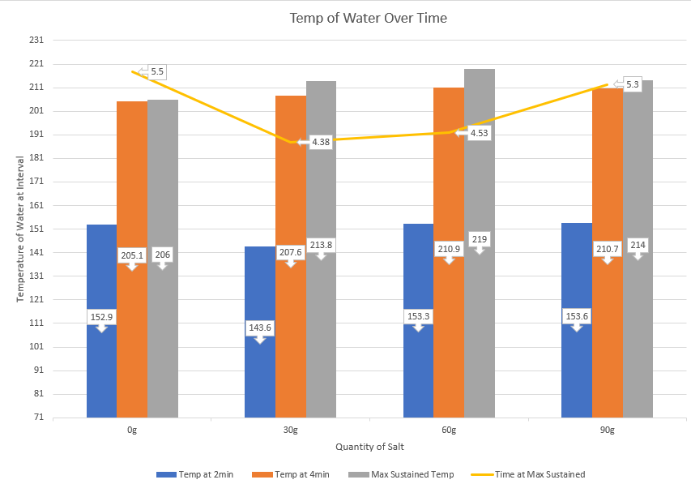

***Section V: Conclusions***

K. The hypothesis was only partially confirmed and further testing would need to be conducted as the results showed that when going from 60g of salt to 90g of salt added to the water the results appear to refute the hypothesis. So, with this I can conclude that there is a limit to the amount of salt you would add to a given amount of water to maintain the hypothesis. This tells me that the amount of the water is in conjunction with the amount of salt added to the water. To be able to continually increase the boiling point, if more salt is added then you would also need to add more water.

L. The only uncontrolled variable will the electric stove. This is controlled as much as possible but cannot guarantee with 100% certainty that the maximum temperature achievable on the stove burner will not fluctuate even when wet to high.

M. Geggel stated that the boiling point of water does change as more salt is added or is more water is added and this will affect the time and temperate needed to achieve a boil (Geggel, 2016). Helmenstine also stated that adding particles to water will raise the boiling point of the water because the particles in the solution also exert pressure to cause the water to boil and not just the atmosphere (Helmenstine, 2019). My testing results confirmed the research that adding salt to water will increase the boiling point of the water but is also confirmed that it shortened the time needed to reach the boiling point. I think further research is needed to confirm the limits of how much salt could be added to 700g of water at 554’ above sea level before the result show the opposite and reflect that the time to boil I longer and the boiling point temperature is higher.

***Section VI: Sources***

N. Geggel, L. (2016, September 22). Does Salt Make Water Boil Faster?. Retrieved from <https://www.livescience.com/56214-does-salt-make-water-boil-faster.html>

Helmenstine, A. M. (2019, June 28). Why Adding Salt to Water Increases the Boiling Point. Retrieved from <https://www.thoughtco.com/adding-salt-increases-water-boiling-point-607447>